数字政府/智慧城市
Digital government/smart city

中国通服是国内最早从事数字政府&智慧城市业务的团队之一。近万名咨询规划师的专家团队，及全行业咨询规划服务能力可为客户提供咨询规划、行业集成、项目管理等领域的全过程服务。
截止目前，中国通服已经有了100多个数字政府&智慧城市顶层规划和实施案例，主要包括：数字广东、四川数字政府、贵阳数字孪生城市、智慧南京、智慧雄安、智慧深圳、智慧前海等标杆案例。
China Comservice is one of the earliest teams engaged in digital government & smart city business in China. The expert team of nearly 10,000 consulting planners and the whole industry consulting and the capability of planning service can provide customers with the whole process services in the fields of consulting and planning, industry integration, project management and so on.
Up to now, there have been more than 100 cases of digital government & smart city top-level planning and implementation, mainly including: Digital Guangdong, Sichuan Digital Government, Guiyang Digital Twin City, Smart Nanjing, Smart Xiongan, Smart Shenzhen, Smart Qianhai and so on.

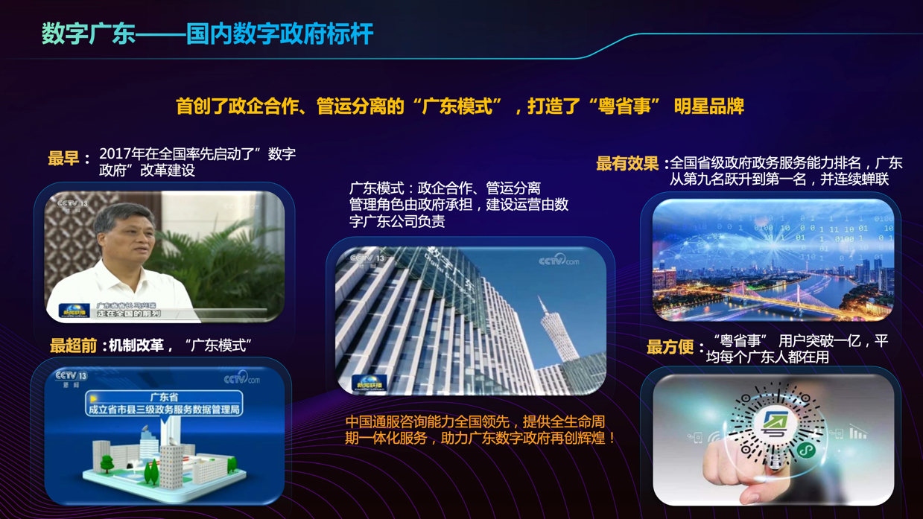
数字广东——国内数字政府标杆
首创了政企合作、管运分离的“广东模式”，打造了“粤省事” 明星品牌
Digital Guangdong: the benchmark of digital government in China

It pioneered the "Guangdong mode", which is the cooperation between government and enterprises and the separation of management and operation, and created the star brand of "YUESHENGSHI".

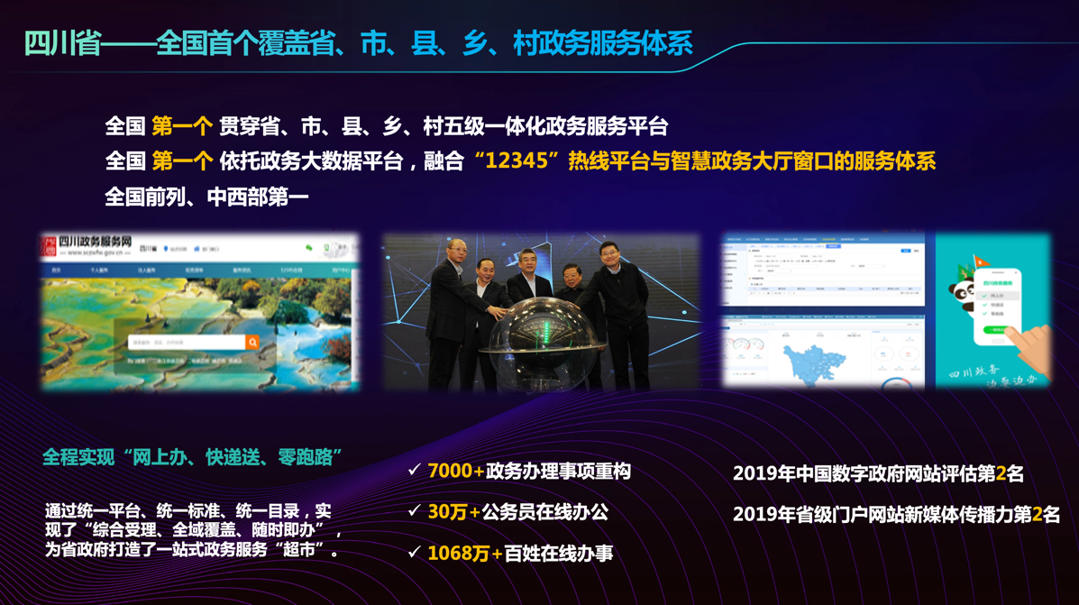
四川省——全国首个覆盖省、市、县、乡、村政务服务体系
全国 第一个 依托政务大数据平台，融合“12345”热线平台与智慧政务大厅窗口的服务体系
全程实现“网上办、快递送、零跑路”
In Sichuan province: the first government service system covering the province, city, county, township, village.
The country’s first service system, it is based on the government big data platform, and the integration of the “12345”hotline platform and the window of smart government hall.
Full implementation of “Online office, express delivery, Zero Run.”

智慧南京中心——国内智慧城市标杆
全国 第一个 特大型智慧城市运营管理平台。
全国 第一套 集资源融合、协同管理、聚合应用为一体的软件模型。
全国 第一套 以空间、时序、密度为一体化线索的智慧城市数据仓库。
The center of Smart Nanjing -- the model of smart city in China.

The first large-scale smart city operation and management platform in China.

The first set of software model in China, which integrates resource fusion, collaborative management and convergent application.

The first National Smart City Data Warehouse, which is to space, time series, density as an integrated clue.

